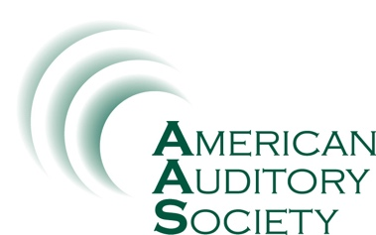

ABSTRACT PREPARATION FORM

You may use this form to prepare your abstract then copy/paste into the AAS abstract submission site.

Abstract Title (not to exceed 10 words)

Structured Abstract

Limit the abstract to 500 words. Do not cite references in the abstract. Limit the use of abbreviations and acronyms. Use the following subheads:

OBJECTIVES. State the objective or question addressed by the research. Any hypothesis should also be stated.

DESIGN. Describe the basic experimental design of the study. The number of subjects and how they were selected should be provided.

RESULTS. State the main results of the study.

CONCLUSIONS. State the conclusions of the study that are directly supported by the data, along with the clinical implications or applicability.

Provide a brief biographical sketch of the presenting author, not to exceed 100 words.

Learner Outcomes
List as many as are practical for the length of the presentation.
Leaner outcomes should complete the following sentence:
"After this presentation, participants will be able to..." To complete this sentence, follow with a measurable action verb such as: describe, demonstrate, solve, identify, compare, contrast, evaluate, prepare, summarize, and write. Verbs to avoid: know, understand, learn, comprehend, and believe.

